CougarConnect How To:
Creating News Posts

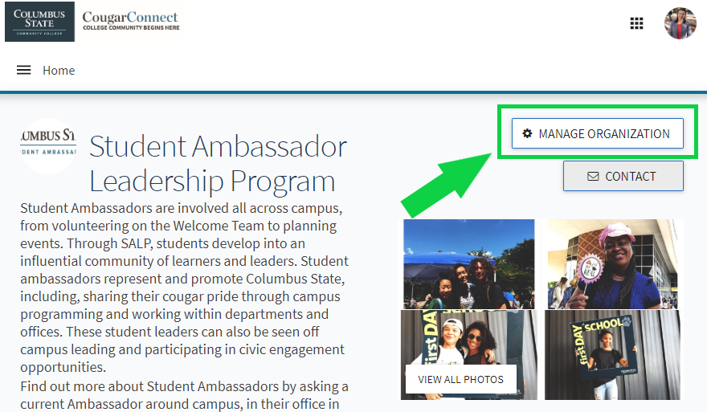
Step 1. Navigate to your page on CougarConnect and enter the “Edit Mode”.
Log in to CougarConnect. Find your page and select the button that says ‘Manage Organization’ to enter “Edit Mode” where you can create and edit content.

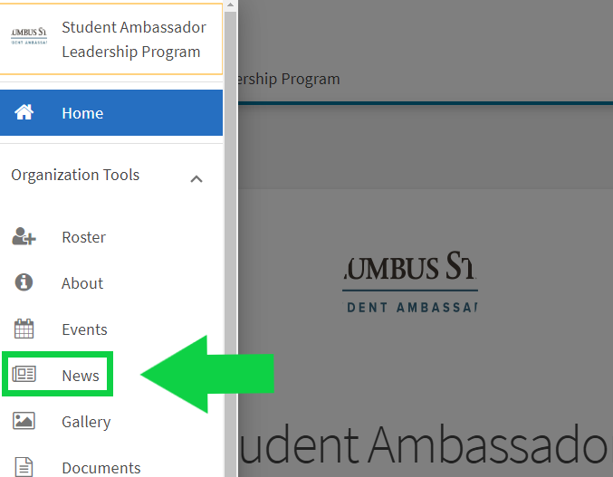

Step 2. Think ‘Pancakes’! After selecting ‘Manage Organization’, you’ll select the 3 horizontal lines that look like a stack of pancakes. This ‘Pancake Button’ will open your Organization Tool Drawer.
Next, you’ll click ‘News’ to open the page where you can create a Pews Post. Look to the top right of this page to find where the blue button says ‘Create Article’.

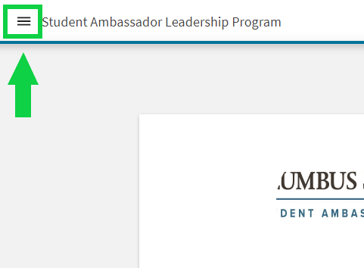

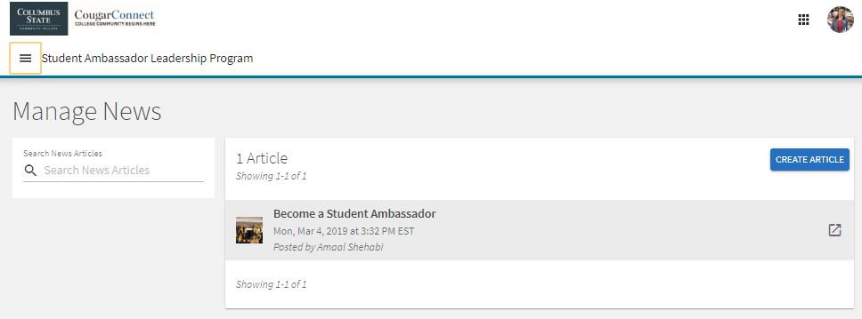

Step 3. Create your news post and select the visibility.
There are 4 visibility options: Public, Institution, Organization, and Private. Don’t forget to add a photo to your news post and include a caption for universal accessibility. If you want an email sent out that alerts your members that there is a news post, simply select the box that notifies all members. This will send a message to everyone you have made the news post visible to.


