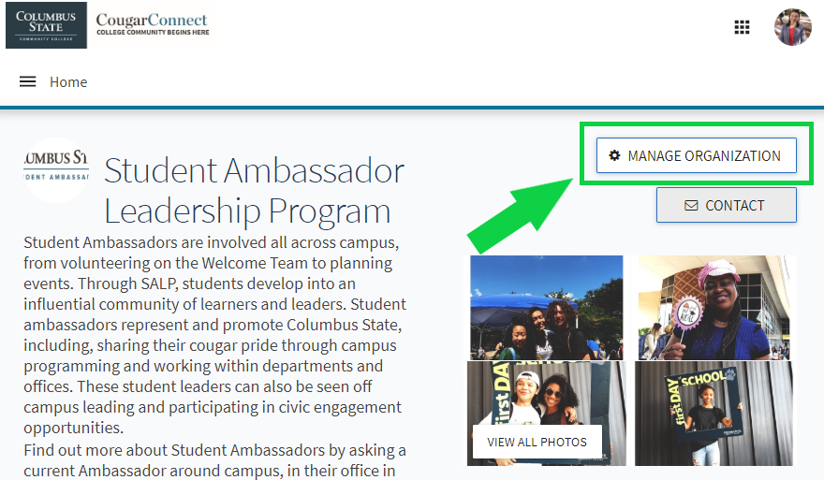
Step 1. Navigate to your page on CougarConnect and enter the “Edit Mode”.
Log in to CougarConnect. Find your page and select the button that says ‘Manage Organization’ to enter “Edit Mode” where you can create and edit content.
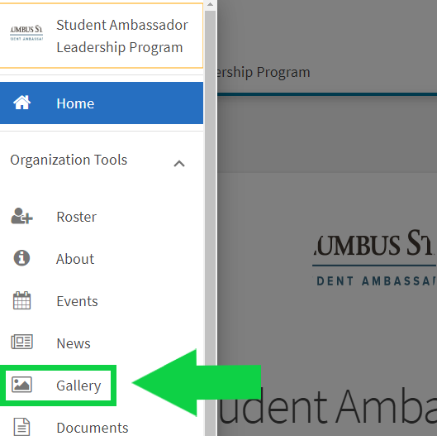
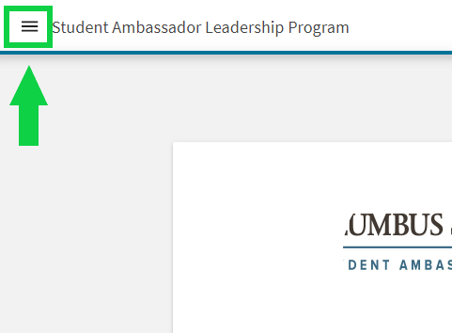
CougarConnect How To:
Add Photos to Your Gallery

Step 2. Think ‘Pancakes’! After selecting ‘Manage Organization’, you’ll select the 3 horizontal lines that look like a stack of pancakes. This ‘Pancake Button’ will open your Organization Tool Drawer.
Next, you’ll select ‘Gallery’ and then the blue ‘Create Album’ button. Next, you can add a name, description, and as many photos as you like. Last step is to select the visibility of your photo album. You can choose Public, Institution, Organization and Private.

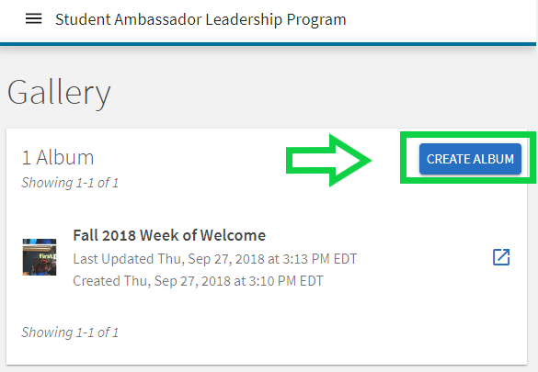

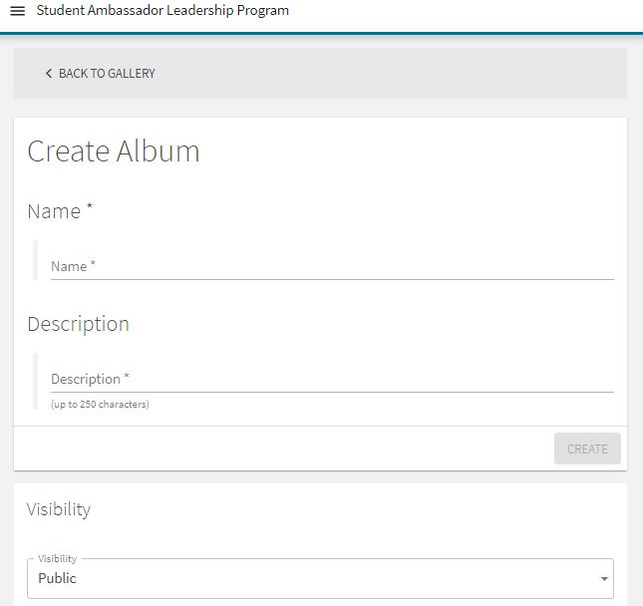

Here’s an example of a completed photo album.

