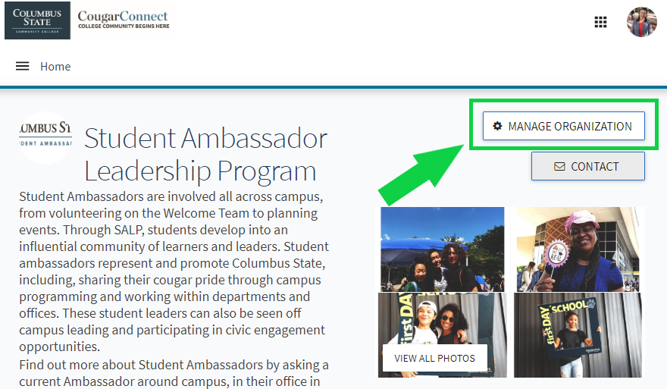
CougarConnect How To:
Create Forms for Feedback
Step 1. Navigate to your page on CougarConnect and enter the “Edit Mode”.
Log in to CougarConnect. Find your page and select the button that says ‘Manage Organization’ to enter “Edit Mode” where you can create and edit content.

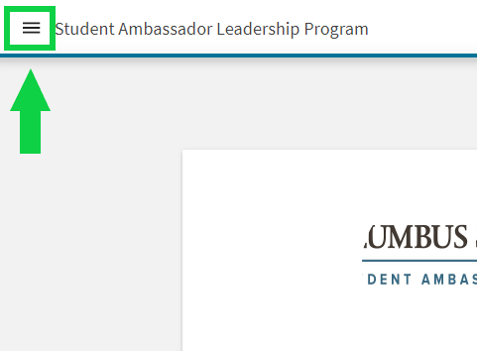
Step 2. Think ‘Pancakes’! After selecting ‘Manage Organization’, you’ll select the 3 horizontal lines that look like a stack of pancakes. This ‘Pancake Button’ will open your Organization Tool Drawer.
Next, you’ll select ‘Gallery’ and then the blue ‘Create Album’ button. Next, you can add a name, description, and as many photos as you like. Last step is to select the visibility of your photo album. You can choose Public, Institution, Organization and Private.

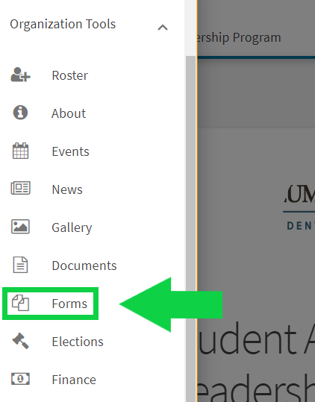

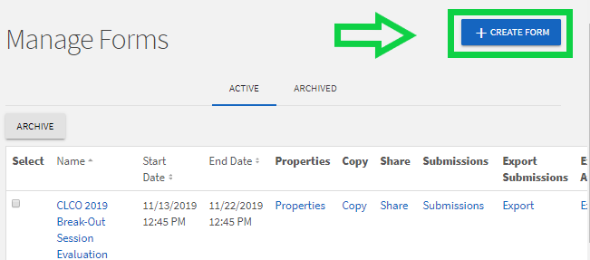

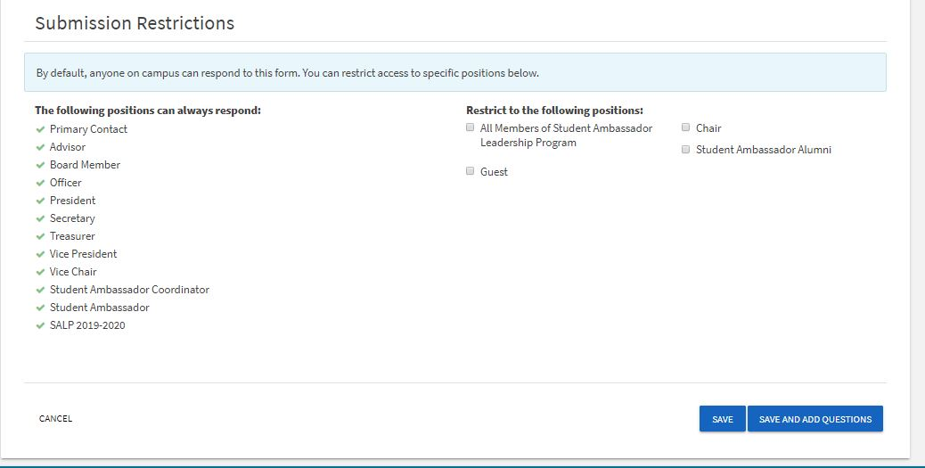
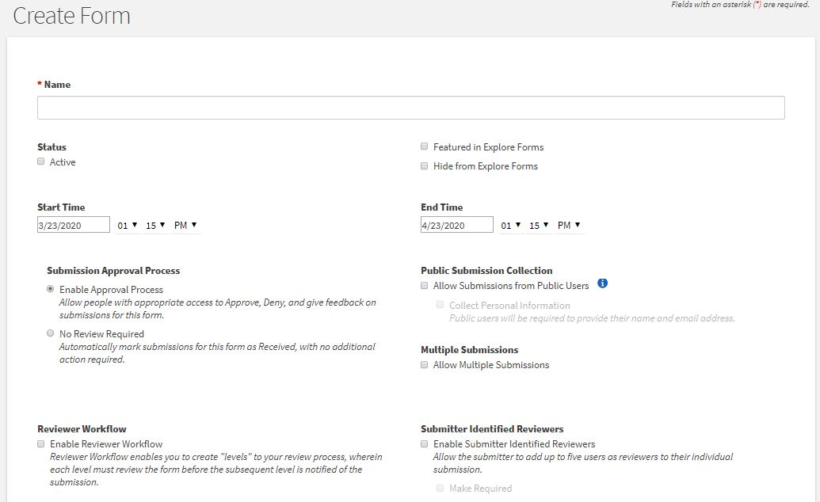
You can click here to let folks respond to the form without logging in to CougarConnect.
If you want them to log in, you can allow them to submit responses multiple times by clicking here.
The End Time is when it will stop receiving responses. You can change these to fit your needs.

Your Start Time is when your form will start receiving responses.
Make sure to check this box when you’re ready for folks to start filling out your form.
Only click here if you want only certain people on your page to respond to this form.

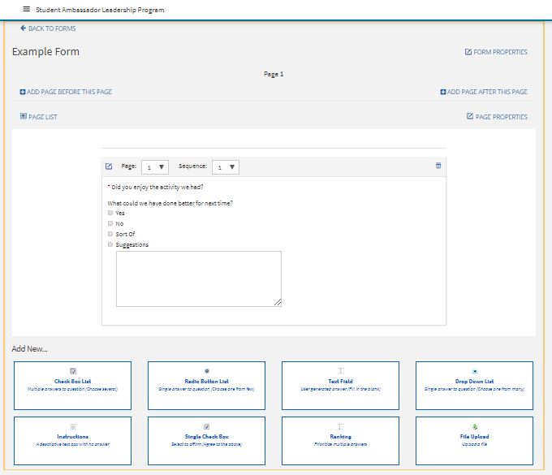
You can add questions down here. There are 8 different types of questions. Read over the descriptions of the question types to decide which would be best, i.e. choose several, choose one, enter text, etc.
On this page is where you can begin to add questions. You can change details about the form itself under Form Properties. You can change the details about each individual page on Page Properties. You can add additional pages as needed. You can also look at your Page List.

