CougarConnect How To:

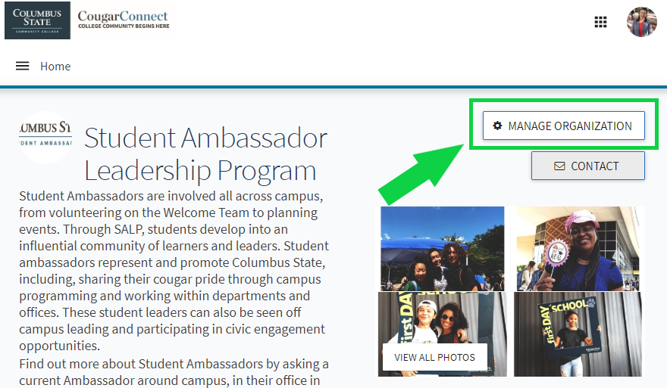
Messaging: Text And Email
Step 1. Navigate to your page on CougarConnect and enter the “Edit Mode”.
Log in to CougarConnect. Find your page and select the button that says ‘Manage Organization’ to enter “Edit Mode” where you can create and edit content.

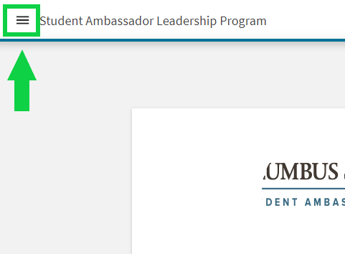

Step 2. Think ‘Pancakes’! After selecting ‘Manage Organization’, you’ll select the 3 horizontal lines that look like a stack of pancakes. This ‘Pancake Button’ will open your Organization Tool Drawer.
Next, you’ll click ‘Roster’ to open the list of people who have joined your page. Look to the top right of this page to find where it says ‘Messaging’.

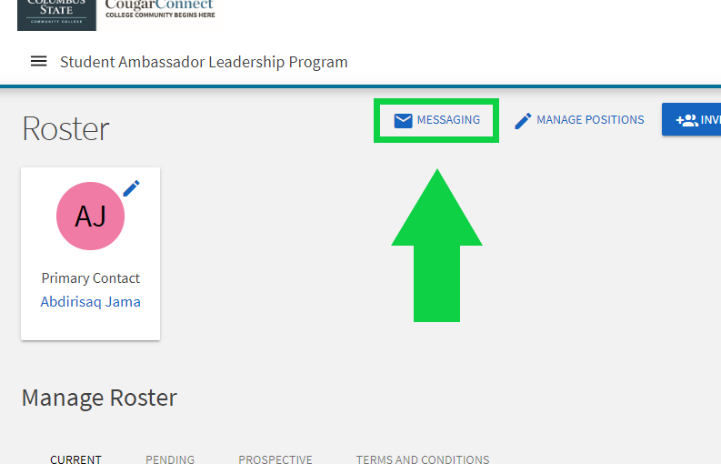

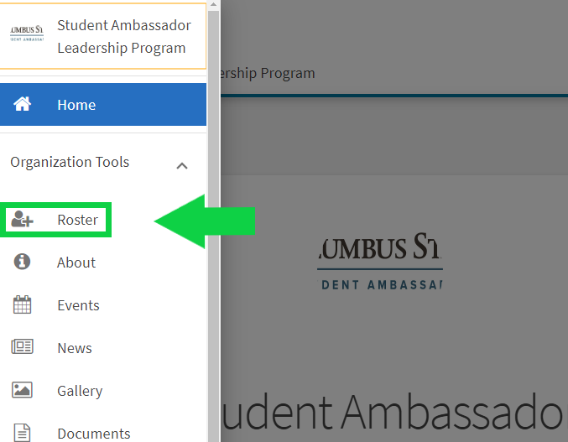

Step 3. Select whether you would like to send a message via email or text.
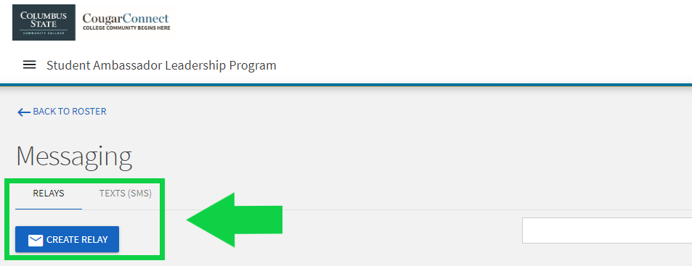

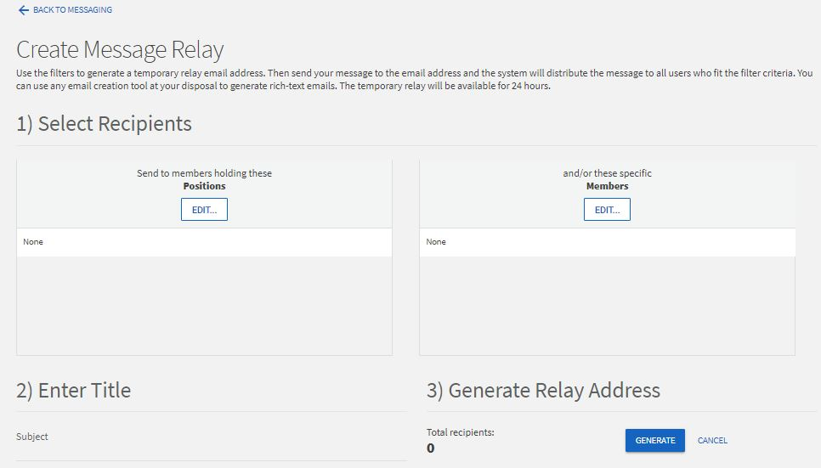
Email Message Part 1
Select which members of your page you would like to message. You can do this by selecting them individually by name or by selecting the position that they hold, for example, Student Ambassador. Then select ‘Generate’.

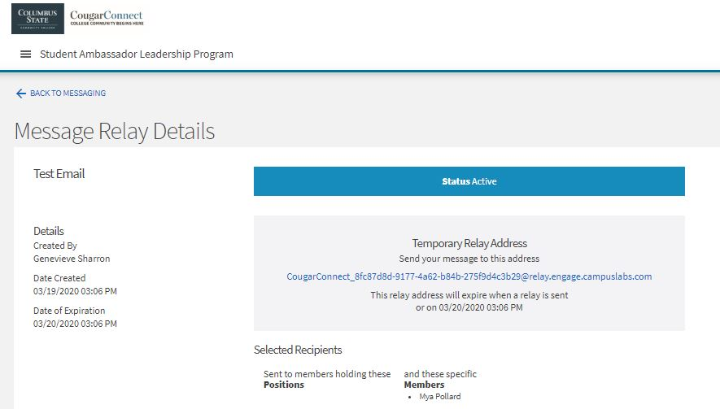
Email Message Part 2
Copy the Temporary Relay Address (email address in blue text), open a new email in your Outlook, and add this into the "To" field. Then, just compose and send your message as normal!

Text Message
Simply select your recipients either by name or the position that they hold, type up the message, and send!



